**Practical-1**

**Aim: Write a C program to count the frequency of each character in a string.**

**Program:**

#include <stdio.h>

int main()

{

char s[1000];

int i,j,k,count=0,n;

printf("Enter the string : ");

gets(s);

for(j=0;s[j];j++);

n=j;

printf(" frequency count character in string:\n");

for(i=0;i<n;i++)

{

count=1;

if(s[i])

{

for(j=i+1;j<n;j++)

{

if(s[i]==s[j])

{

count++;

s[j]='\0';

}

}

printf(" '%c' = %d \n",s[i],count);

}

}

return 0;

}

**Output:**

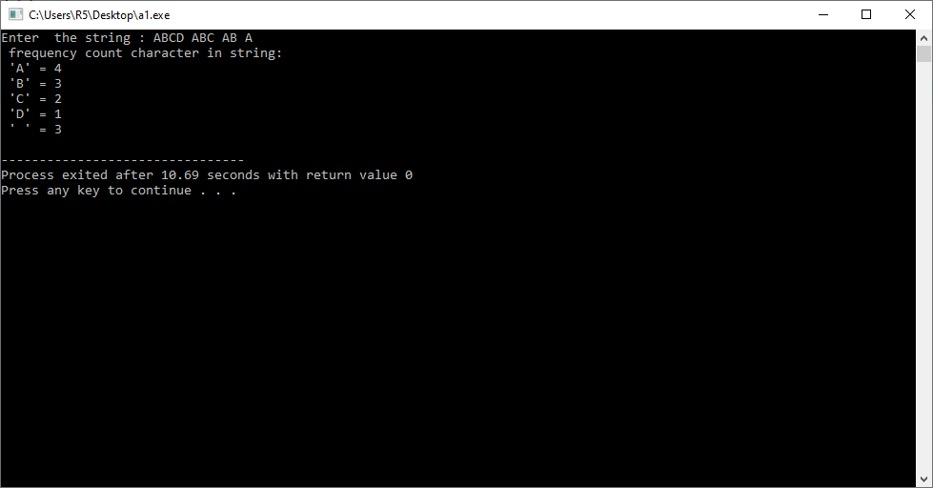

**Practical-2**

**Aim**:**Write a C program to check whether a string is a palindrome or not.**

**Program:**

#include <stdio.h>

int main()

{

char string1[20];

int i, length;

int flag = 0;

printf("Enter a string:");

scanf("%s", string1);

length = strlen(string1);

for(i=0;i < length ;i++)

{

if(string1[i] != string1[length-i-1])

{

flag = 1;

break;

}

}

if (flag)

{

printf("%s is not a palindrome", string1);

}

else

{

printf("%s is a palindrome", string1);

}

}

**Output:**

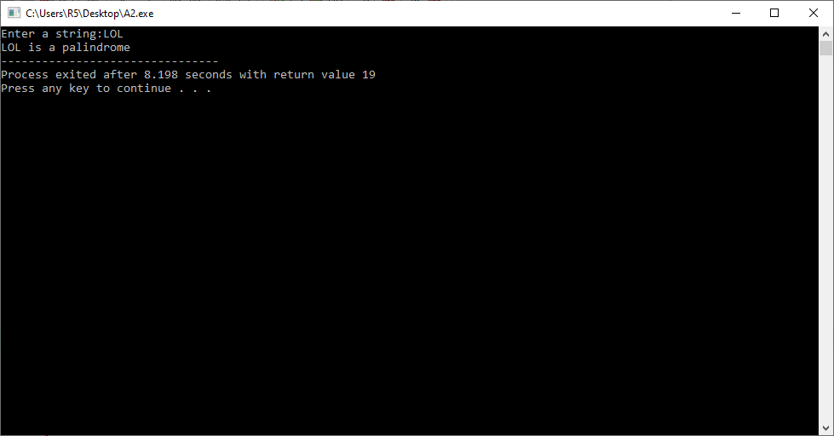

**Practical-3**

**Aim: Write a C program to remove spaces, blanks from a string.**

**Program:**

#include<stdio.h>

int main()

{

char str[50];

int i=0, j, chk;

printf("Enter a String: ");

gets(str);

while(str[i]!='\0')

{

chk=0;

if(str[i]==' ')

{

j=i;

while(str[j-1]!='\0')

{

str[j] = str[j+1];

j++;

}

chk = 1;

}

if(chk==0)

i++;

}

printf("\nString (without spaces): %s", str);

getch();

return 0;

}

**Output:**

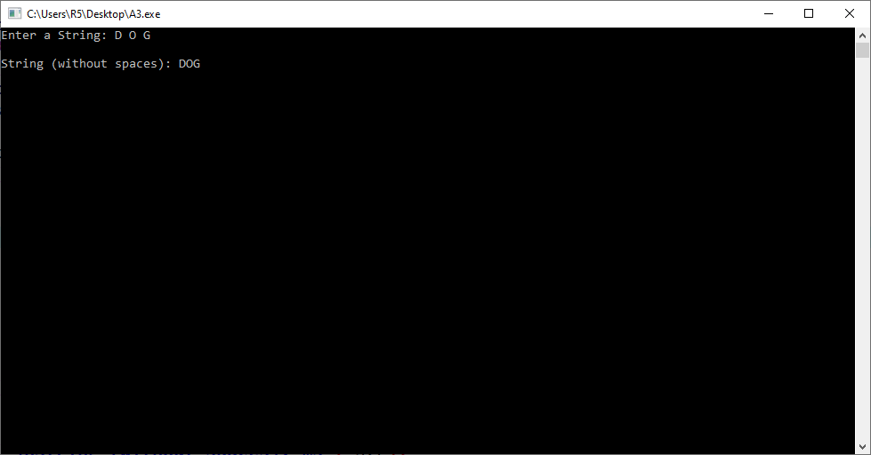

**Practical-4**

**Aim:Write a C program to remove all repeated characters in a string.**

**Program:**

#include <stdio.h>

int main()

{

char str[100];

int i, j, k;

printf("\n Please Enter any String : ");

gets(str);

for(i = 0; i < strlen(str); i++)

{

for(j = i + 1; str[j] != '\0'; j++)

{

if(str[j] == str[i])

{

for(k = j; str[k] != '\0'; k++)

{

str[k] = str[k + 1];

}

}

}

}

printf("\n The Final String after Removing All Duplicates = %s ", str);

return 0;

}

**Output:**

